Five in One 4CH SD Card 1080P Mobile DVR
机（8路1080N硬盘机）

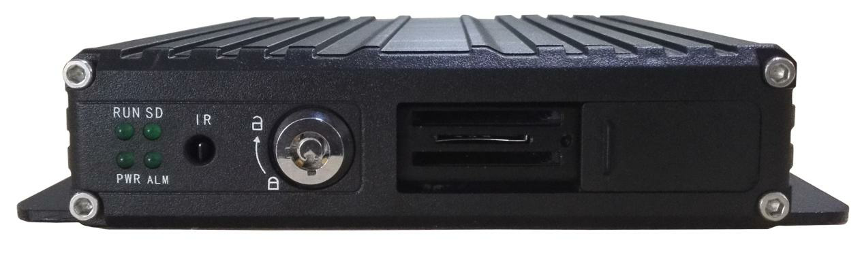

FEATURES:

Built-in high performance Hisilicon chipsets, coded with H.264/H.265 standard, high compression rate and image quality
- AHD/TVI/CVI/IPC/ANALOG five in one video input, wide compliance
- 4+1 live preview and storage
- 1CH synchronized AV output, 1CH VGA output
- Support UPS power input
- Built-in G-sensor, monitor the driving habits
- Reverse Assistance
- Adjust the camera image horizontally and vertically
- Adjust the camera image 90 degrees
Power:
- Professional In-Vehicle power design, 8-36V DC Wide Voltage Range
- Multiple protection circuits like under-voltage, short, reversed plug-in
- Smart power management system, shutdown under low voltage, low consumption when standby
- Report the GPS info to the server regularly with very low power consumption, compliant with JT/T794-2011 standard
Data Storage:
- Built-in super capacitor to avoid data loss and disk damage caused by sudden outage
- Special file management system to encrypt and protect the data
- Proprietary technology to detect the bad track of the disk which can make sure the continuity of video and long service life of the disk
- Support SD card storage, maximum 256GB
Transmission Interface:
- Support GPS/BD/GLONASS optional, high sensitivity, fast positioning
- Support wireless download by WiFi, 802.11b/g/n, 2.4GHz
- Support 3G/4G transmission, LTE/HSUPA/HSDPA/WCDMA/EVDO/TD-SCDMA

Technical Parameter:
Item | Device Parameter | Performance
System | Main Processor | Hi3520DV400
 | Operating System | Embedded Linux OS
 | Operating Language | Chinese/English/Russian
 | Operating Interface | GUI, Support mouse and remote control
 | Password Security | Two Layer password Admin/User
Audio  &  Video | Video Standard | PAL/NTSC
 | Video compression | H.264/H264+/H265/H265+
 | Image resolution | 1080P/720P/960H/D1/CIF
 | Playback Quality | 1080P/720P/960H/D1/CIF
 | Compound mode | A variety of ways
 | Decoding ability | 4ch 1080P
 | Recording quality | Class 1-6 optional
 | Image display | Single/QUAD display optional
 | Audio Compression | G.726/G.711
 | Audio recording | Audio & Video synchronized recording
Recording & Playback | Recording mode | Manual/Alarm
 | Video bit rate | Full frame 4096Mbps，6 classes image quality optional
 | Audio bit rate | 8KB/s
 | Storage media | SD card storage
 | Video inquiry | Inquiry by channel/Recording type/Alarm Type
 | Local playback | Playback by channel, time
Firmware upgrading | Upgrading mode | Manual/Automatical/Remote/Emergency Recovery
 | Upgrading method | USB disk/Wireless network/SD card
Interface | AV input | 4ch 4pin aviation + 1ch 6pin aviation for IPC
 | AV output | 1ch VGA video output, 1ch aviation AV output
 | Alarm input | 4 digital inputs (4 Positive/Negative trigger)
 | SD card | 1 SDXC High speed card (up to 256GB)
 | USB interface | 1 USB 2.0 (support pen drive/mouse)
 | Ignition input | 1 ACC signal
 | UART | 1 LVTTL Level
 | LED Indication | PWR/RUN/SD/ALM
 | Ethernet | 1 x 6 pin aviation to RJ45 (10M/100M)  750mA@12V
 | IR | 1
 | Disk lock | 1
 | Debug port | 1
Function Extension | GPS/BD/GLONASS | Support detecting antenna Plug in/Unplug/Short circuit
 | 2G/3G/4G | Supports CDMA/EVDO/GPRS/WCDMA/FDD LTE/TDD LTE
 | WIFI | 802.11b/g/n, 2.4GHz
Others | Power input | 8V~36V DC
 | Power output | 5V 300mA
 | Power consumption | Standby 8.5mA  Maximum consumption 18W @12V 1.5A @24V 0.75A
 | Working temperature | -20 --- 70℃
 | Storage Size | 1080P 1G/h/channel  720P 0.5G/h/channel  960H 0.38G/h/channel
 | Dimension | 142*153*33mm

